Design of Local Client and Worker:

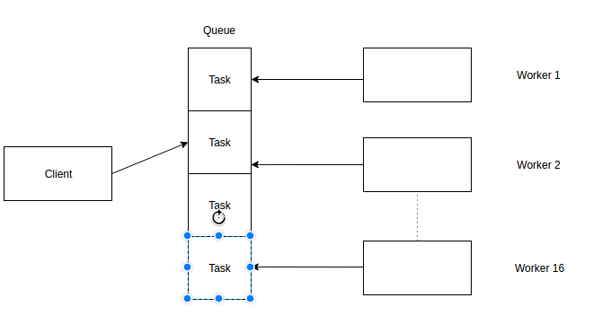
Description:
- Both client and worker are running on same machine.
- A queue will be maintained in memory.
- Client will push tasks one by one to the queue.
- Worker threads will work in background.
- They will fetch tasks one by on from the queue

Design of Remote Client and Workers:

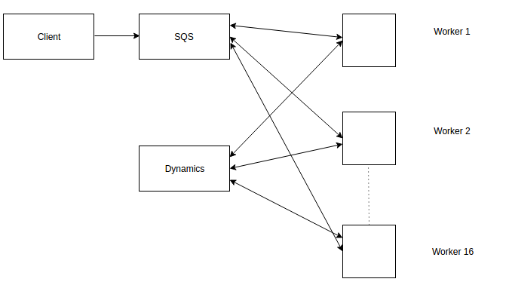
- Client and worker are running on different machines.
- SQS queue services will be used by client to load all tasks from workload file
- Client will push tasks one by one to the SQS.
- Workers will fetch these tasks from SQS
- Worker will then insert the fetched task in DynamoDB.
- When the tasks are unique, worker will execute them else discard them

